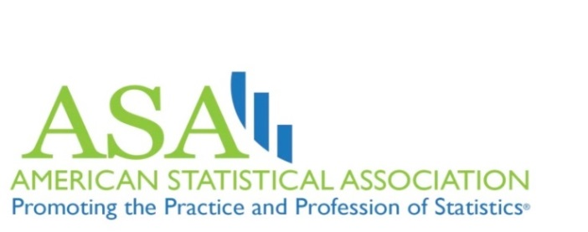

Differential Privacy: Protecting Individuals from Re-Identification

Dan Kifer  Vishesh Karwa  Aleksandra Slavkovic | A FREE webinar featuring:  Daniel Kifer, Pennsylvania State University  Vishesh Karwa, Harvard University  Moderator  Aleksandra Slavkovic, Pennsylvania State University  Friday, February 10, 2017, 1:00-2:00 p.m. EST  Twitter Hashtag: #ASAwebinar  Sponsored by the ASA-Privacy & Confidentiality Committee  Differential privacy is a statistical framework for protecting privacy interests in statistical databases by focusing on the disclosure risk to an individual being included in a data set. In this webinar, two research experts explain this methodology and how they apply differential privacy methodology as a data protection method for protecting data files from the risk of re-identification. A key benefit of the Differential Privacy methodology is that in many cases, appropriate privacy protection can be achieved if random noise is properly added to the actual results. For example, rather than simply reporting the sum, the data provider can inject noise based on a distribution. The calculation of “how much” noise to inject can be made based only on knowledge of the function to be computed. This webinar will cover the basic principles of differential privacy, how it works, and how it can successfully be applied to current statistical databases.  Kifer is currently on sabbatical at the U.S. Census Bureau investigating applications of differential privacy to official statistics. Karwa is currently working on combining statistical and cryptographic approaches for data privacy while privacy preserving statistical inference.

Registration: This webinar is free, but registration is required:
https://www.amstat.org/ASA/Education/Web-Based-Lectures.aspx.

