How to Join the JSM 2016 Discussion Group
To join the JSM 2016 Discussion Group, follow the steps below.
- Visit amstat.org.
- Click on the blue “Login” tab at the top of the page.
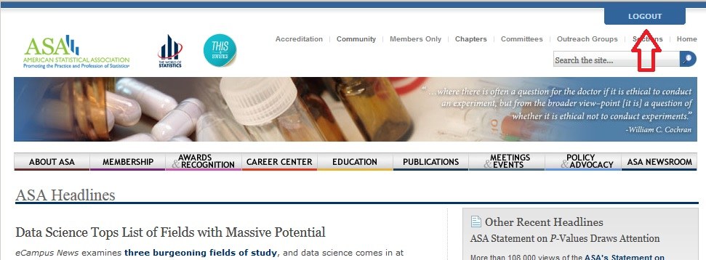
- You’ll be prompted to enter a username and password. If you’re an ASA member, enter the username and password you usually use to log in to amstat.org. If you’re not an ASA member, enter the username and password you created when you registered for JSM 2016.
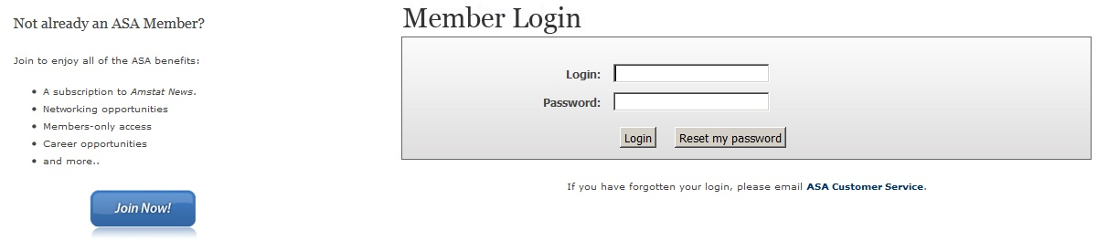
- Once you’ve logged in, click here (or copy and paste this link into your web browser: http://community.amstat.org/communities/community-home?CommunityKey=e3ec3a21-9524-464f-8290-36b14e8e6378 ).
- Click the gray “Settings” button next to the words “2016 Joint Statistical Meetings.”
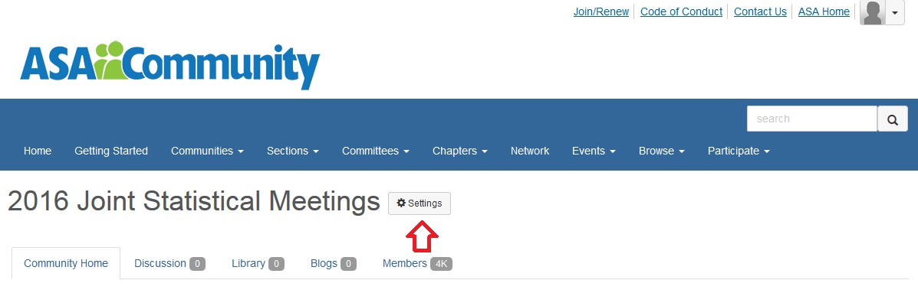
- Click on the blue button that currently says “No Email.”
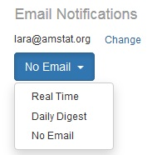
- If you want to get a roundup of the previous day's posts each morning, choose “Daily Digest.” If you want to receive new posts when they're posted (handy for organizing a lunch or other on-the-fly meetup), choose “Real Time” from the options in the drop-down menu that appears. Once you’ve chosen an option, the button will turn green with a checkmark.
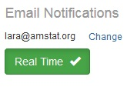
To participate in discussions once you’ve subscribed:
- If you want to start a new discussion, click on the "Discussion" tab, and then click "Post New Message.”
- If you want to reply to an ongoing discussion, click on the "Discussion" tab, then click on the subject line of the discussion you want to reply to, scroll down, and click the blue "Reply to eGroup" button.
You will also receive discussion posts in your email inbox, and can start and reply to discussions via email, as well.
Have more questions? Need help?
- If you want more details on posting to ASA Community discussion groups, see this tutorial video.
- If you have other questions, contact us here.
Last updated 5/19/16, by Lara Harmon

